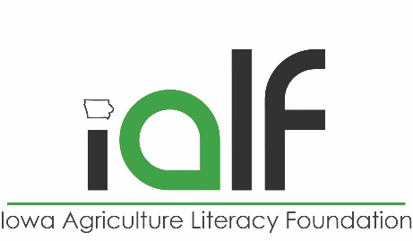

GMOs & Organic Agriculture Pre-Test

Answer the following questions as best as you can with just your prior knowledge. Don’t worry if you don’t know an answer – it is okay to guess. Keep these questions in mind as your learn more about GMOs and organic agriculture.

1. What does GMO stand for?
   1. Gene modified other
   2. Genetically modified organism
   3. Great many options
   4. Gene molecule organism
2. Where are you most likely to find a GMO?
   1. A tomato farm
   2. A potato farm
   3. A sugar beet farm
   4. A watermelon farm
3. Organic food producers can grow genetically modified crops.

True/False

1. What are some reasons a farmer might grow a genetically modified crop?
   1. It resists disease
   2. It is more nutritious
   3. It can protect itself from harmful insects
   4. All of the above
   5. None of the above
2. Organic food is more nutritious than conventionally raised food.

True/False